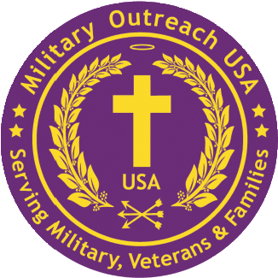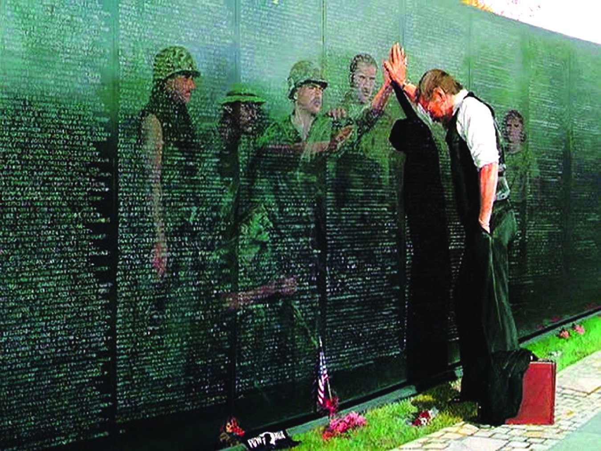

**Military *Outreach USA***

***& Stand-By-My-Heroes NFP***

3020 Milwaukee Ave – Northbrook IL 60062 (877) 734-4244 – www.Militaryoutreachusa.org

**Veterans Fundraiser – Schaumburg Boomers @ Wintrust Field**

**An afternoon of baseball for the whole family**

**Mission**. Reduce the Veteran suicide rate of **22+** per day and the growing number of First Responders. Our programs offer prevention & best practices to those struggling with the invisible scars of war. If you are quietly challenged and seek restoration and recovery we will support you at no cost.

**Stand-By-Me-Heroes.** Rescuing our heroes one at a time struggling with the invisible scars of war. Our focus spans Moral Injury, Post-Traumatic Stress, Military Sexual Trauma, and TBI to mind, body and soul at no cost to Veterans & First Responders utilizing our trained Foxhole Soul Counselors.

**Veterans Exiting Homelessness**. To date we have provided over 3,000 beds in our Beds-for-VETS Project and distributed over a million dollars in Move-In-Essentials Project to over 70,000 veterans at no charge. This we have accomplished with our Regional Partners of the VA HUD-VASH Teams.

**Moral Injury Research**. Dr. John Bair and team are working on research to promote understanding and best treatments of Moral Injury. Veterans interested in participating in our Eye-Tracking research via a 50-minute person-to-person Q&A session please call 877-734-4244.

_______________________________________________________________________________________

**SBMH Veterans Community Center Initiative,** location Cook County Hanover Park IL. Rescue our heroes and strengthening our partnerships with VA hospitals/CBOCs, Project Management training via Pifer Communications and VA Regional HUD-VASH teams. These are the actions of a grateful nation restoring mind, body and soul across communities.

______________________________________________________________________________________

**Sponsorship Opportunities**

Please sponsor veterans, active-duty personnel and families and purchase tickets.

**Honorary** $500 = 10 tickets, 2 gift bags **Gold** $2,500 = 40 tickets, 15 gift bags

**Bronze** $700 = 20 tickets, 5 gift bags **Platinum** $5,000 = 50 tickets, 20 gift bags

**Silver**  $1000 = 30 tickets, 10 gift bags

Sponsors will have an opportunity to meet **Major General** (retired) **James H. Mukoyama**, and will be honored at the game and in our newsletter.

**Send checks to** : Military Outreach USA 3020 Milwaukee Ave – Northbrook IL 60062

Purchase tickets here: <https://www.tixr.com/groups/boomersbaseball/events/schaumburg-boomers-vs-washington-wild-things-125932?plt=8e236d0d-df83-4848-9a54-f3c489d6b90c>

