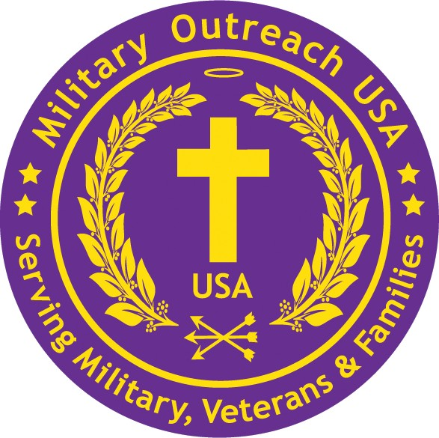
Military Outreach USA 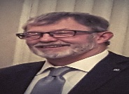
700 Florsheim Drive suite 11 Libertyville, IL 60068 • 877-734-4244 www.MilitaryOutreachUSA.org

Dr Bair. UPDATE: PTSD/TBI/Moral Injury meetings
Friday, September 8, 2023 at 08:00:52 PM CDT, John Bair <john.bair@comcast.net> wrote:

My research work with the PTSD/TBI/Moral Injury Spectrum continues. We have just completed a study on identifying underlying themes within a population of Veterans with Moral Injury/Moral Distress (MI/MD). Currently we are preparing a study to investigate Eye tracking as a measure of MI/MD. We are next interested in Eye tracking as a measure for Traumatic Brain Injury (TBI).

We invite students to consider involvement with these efforts. Currently we have one RFU medical student, a Chicago School Psy.D. student, and a Loyola Pastoral Counselor training in our Eye tracking Lab. My colleague, Danielle Ciccone-Coutre, PHD, ABPP, is my associate with this Lab. We would be most interested in having 2-3 additional students from Rosalind Franklin Medical on our Team.

One of our goals is to raise money through grants and fundraising. I ask your support with having Military Outreach USA as a co-sponsor with North Chicago Rotary of a fundraiser to support this research. Money would come to Military Outreach USA to allocate for research and scholarship support.

In November we will have 3 four-hour trainings in Eye tracking provided by Eye link expert trainers. This is proposed to be supported by Military Outreach USA.

A proposed fundraiser idea is a Veterans Day Concert to be held at College of Lake County. Rotary Leaders would work with arranging a Band and Military Outreach USA would assist Rotary with preparation and promotion.

May I speak with you about this matter at a time of your convenience.

Thank you for your consideration.

Most Respectfully, John

